**Web Technology**

Project Report

on,

**A SOCIAL NETWORKING SITE**

**Greeto**

Submitted By,  
Kavya M (4JC12CS045)  
KruthiMallik B C (4JC12CS049)  
Sindhura B R(4JC12CS109)

Under the guidance of,  
Prof. Brunda S  
Dept of Computer Science

S.J.C.E,MYSORE



**PROJECT CERTIFICATE**

This is to certify that the project report entitled “***A SOCIAL NETWORKING SITE***

” submitted by **Kavya.M(4JC12CS045),KruthiMallik.B.C(4JC12CS049) and Sindhura.B.R(4JC012CS109)** to **Sri Jayachamarajendra college of Engineering, Mysore** in fulfilment of the requirement for the internal assessment in **Web Technology** is a record of bonafide work carried out by them under my guidance. The project fulfils the requirements as per the regulations of this assessment and in my opinion meets the necessary standards for submission

<Signature>

Project Guide

Date:15-11-2014

**Contents**

1. Introduction…………………………………………………………………………....3
   * 1. Objectives of the project……………………………………………………....…..4
     2. Features of the project…………………………………………………………….5
2. System requirement specification…………………………………………………….6
3. System Design…………………………………………………………………....…..7
   * 1. ER diagram high level data modelling………………………………………..….9
     2. Schema diagram conceptual data modelling …………………………………...10
     3. State diagram …………………………………………………………………...11
4. Normalization up to 3NF…………………………………………………………...12
5. System Implementation…………………………………………………………….16
   * 1. Introduction to SQL…………………………………………………………….20
     2. SQL commands and their relational algebraic queries…………………………21
6. System Testing and results ………………………………………………………...28
7. Conclusion …………………………………………………………………………35
8. References………………………………………………………………………….36

**Introduction**

A **Social networking service** is a platform to build social networks or social relations among people who,for example, share interests, activities, backgrounds, or real-life connections. A social network serviceconsists of a representation of each user (often a profile), his/her social links, and a variety of additionalservices. Most social network services are web-based and provide means for users to interact over theInternet, such as e-mail and instant messaging. Online community services are sometimes considered asa social network service, though in a broader sense, social network service usually means an individual-centered service whereas online community services are group-centered. Social networking sites allowusers to share ideas, pictures, posts, activities, events, and interests with people in their network.

**Objectives of the project**

The objective of this project is to implement the social networking site similar to g+ to the best satisfaction of the user. The earlier method used for communication was telegraph and telephone system.

Now, we would like to use databases to facilitate this process of establishing communication among large number of people in an attractive manner.

**Specific Objectives**

● Make new user account in more user friendly and proper validation of details

● Search People easily on entire network

● Add people to your friend or family circles

● Add friends to your “add to circle” accept request.

● Creating a public profile having social, professional and personal information

● Ease of editing of profile anytime

● Upload and Share Images on network

● Send messages to other friends

● Reply directly to incoming user messages

● Post Advertisement of products

● Administration page to keep eye on user operation

● Easy password recovery processing

**Features of the Project**

Our Website will be an online community designed to make social life of people more active and stimulating. The social network can help you maintain existing relationships with people and share pictures and messages, and establish new ones by reaching out to people you've never met before.

Here you’ll be adding people to your friend, family circles or following celebrities. You can also follow them based on your interests so that any post from them can be made available to you.

This website also provides the features of blogging all at one place. The main idea behind blogging is to share your thoughts with all your friends which can be read by all the users using the website. This blog can be handled by the user as he wants for example adding photos .This website enhances Advertisements of products. People using this website can buy and sell products from this website. The main purpose behind this advertisement function isto help people to buy products which are trusted in their circle.

According to Boyd and Ellison's (2007) article, "Why Youth (Heart) Social Network Sites: The Role of Networked Publics in Teenage Social Life", social networking sites share a variety of technical features that allow individuals to: construct a public/semi-public profile, articulate a list of other users that they share a connection with, and view their list of connections within the system. The most basic of these are visible profiles with a list of "friends" who are also users of the site. A profile is generated from answers to questions, such as age, location, interests, etc. Some sites allow users to upload pictures, add multimedia content or modify the look and feel of the profile. Others, e.g., Facebook, allow users to enhance their profile by adding modules or "Applications."It allow users to post blog entries, search for others with similar interests and compile and share lists of contacts. User profiles often have a section dedicated to comments from friends and other users. To protect user privacy, social networks typically have controls that allow users to choose who can view their profile, contact them, add them to their list of contacts, and so on.

**System Requirement Specification**

**Hardware Requirements**:  
System with intel dual core processor or higher.

**Software Requirements**:  
Windows XP and higher Or Linux OS  
Firefox or Google chrome browser  
XAMP or LAMP Server to run Apache, MySQL and PHP  
Basic text editor.

* Internet Explorer 8 , 9 ,10 or higher versions
* Google Chrome 25 or higher versions
* Firefox 21 or higher versions

**System Design**

**Description of Tables and Attribute Value**

**Entity Relationship Diagram**

In Computer Science engineering, an entity–relationship model (ER model) is a data model for describing the data or information aspects of a business domain or its process requirements, in an abstract way that lends itself to ultimately being implemented in a database such as a relational database. The main components of ER models are entities (things) and the relationships that can exist among them, and databases.

Entity–relationship modeling was developed by Peter Chen and published in a 1976 paper. However, variants of the idea existed previously, and have been devised subsequently such as

**Relational Schema**

In relational database theory, a relation, as originally defined by E. F. Codd, is a set of tuples (d1, d2, ...,dn), where each element dj is a member of Dj, a data domain. Codd's original definition notwithstanding, and contrary to the usual definition in mathematics, there is no ordering to the elements of the tuples of a relation. Instead, each element is termed an attribute value. An attribute is a name paired with a domain (nowadays more commonly referred to as type or data type). An attribute value is an attribute name paired with an element of that attribute's domain, and a tuple is a set of attribute values in which no two distinct elements have the same name. Thus, in some accounts, a tuple is described as a function, mapping names to values.

**SCHEMA DIAGRAM**

**State Diagram**

A state diagram is a type of diagram used in computer science and related fields to describe the behaviour of systems. State diagrams require that the system described is composed of a finite number of states; sometimes, this is indeed the case, while at other times this is a reasonable abstraction. Many forms of state diagrams exist, which differ slightly and have different semantics.

State diagrams are used to give an abstract description of the [behavior](http://en.wikipedia.org/wiki/Behavior) of a [system](http://en.wikipedia.org/wiki/System). This behavior is analyzed and represented in series of events, that could occur in one or more possible states. Hereby "each diagram usually represents objects of a single class and

planeNo

name

bmax

em

**System Testing and Results**

The main purpose of the test plan for the Greeto site is to discuss the testing details of the use cases of the Greeto site. The software project test plan also describes the objective, scope and approach of the software testing effort for the Greeto site. The test plan for the Greeto site also indicates the personnel responsible for each task and also specifies the risks associated with the test plan.

**DEFINITIONS**

The following are some of the terms and definitions that are related to the test plan of the

Greeto site:

• **Pass/Fail criteria:** Decision rules that are used to determine whether a software item passes or fails a test.

• **Test:** A collection of one or more test cases

• **Test Item:** A software item that is an objective of testing.

• **Test Plan:** A document describing the scope, approach, resources and schedule of the

intended testing activities.

• **Test Summary Report:** A document summarizing the testing activities and results.

• **Testing:** The process of analyzing a software item to detect the differences between the

existing and required conditions.

**TEST ITEMS**

This section of the test plan lists all the items of the Greeto site projectthat will be tested:

* + Signup
  + Login
  + uploading image
  + Add friends or family
  + Posts
  + Visit friends Page

1. **APPROACH**

This section of the test plan describes the overall approach for testing the Greeto site. The approach followed for testing the Greeto site ensures that the major features of the project are adequately tested. The testing would be carried out on the Greeto site while logging into the system as a user of the site.

**UNIT TESTING**

The Unit Testing is a test that tests each single module of the software to check for errors.This is mainly done to discover errors in the code of the Greeto site.

**INTEGRATION TESTING**

In Integration Testing, the individual software modules are combined and tested as awhole unit. The integration testing generally follows unit testing where each module is tested as a separate unit.

**REGRESSION TESTING**

The Regression Testing is generally done whenever modifications are made to the sourcecode of a project. The Regression Testing can also be defined as the process of testing changes made to the computer program and also makes sure that the older programming still works with the new changes.

**ACCEPTANCE TESTING**

This testing is generally performed when the project is nearing its end. This test mainlyqualifies the project and decides if it will be accepted by the users of the system. The users of the project are responsible for the test.

**SYSTEM TESTING**

The system testing is mainly done on the whole integrated system to make sure that the project that has been developed meets all the requirements. The test cases for the system testing will be the combination of unit and integration tests.

**TEST CASES**

The following are the test cases for the Greeto site:

**TEST CASE 1 – USER LOGIN**

• **Incorrect Input:** Incorrect username, which is the email-id in the case of the greeto website

• **Pass Criteria:** An appropriate message should be generated to indicate that an invalid

Username has been typed.

• **Correct Input:** The correct input would be a valid e-mail id of the user and a correct

password associated with the email-id which he uses to log in.

**TEST CASE 2 – USER SIGNUP**

• **Incorrect Input:** Wrong format entered in the input fields for the signup page.

• **Pass Criteria:** An appropriate message should be generated to the user saying that he has entered the wrong format in the specific input field.

• **Correct Input:** The correct input would a correct format entered by the user into the input fields of the signup page.

• **Pass Criteria:** The pass criteria for this test case would be a successful signup of the user into the Greeto site.

**TEST CASE 3 – USER SIGNUP**

• **Incorrect Input:** The data fields left out empty in the signup page.

• **Pass Criteria:** An error message should be generated to the user saying that he has to fill out those fields in order to be registered into the system.

• **Correct Input:** The correct input in this case, would be that the user would enter the data in all the fields in the signup form.

• **Pass Criteria:** The pass criteria for the system would be that it accepts all the user

details and then registers the user and helps him log into the system.

**TEST CASE 4 – SEARCH AND UPLOAD IMAGE**

• **Incorrect Input:** Incorrect input in this case, would be incorrect image.

• **Pass criteria:** A message has to be generated to the user indicating that this image cannot be uploaded or tat its not an image.

• **Correct Input:** A correct input would be entering the image into the data entry fields in a

Correct format.

• **Pass Criteria:** The user can also akip this with the default image.

**PASS OR FAIL CRITERIA**

The test cases executed on the Greeto site will pass if they meet the specific requirements mentioned in the Vision document of the project. A test case is said to fail, if the desired functionality is not satisfied by the system.

**TEST DELIVERABLES**

The following documents will be produced after the testing phase for the Greeto site has been completed.

• Test Plan

• Test Cases& Test Log

**Test Cases and Results**

**TEST CASE RESULT SUMMARY**

The summary of the test case result has been depicted in the table shown below:

These are the test cases for the User/User pages. The major part of testing has been

concentrated on the user pages, as they would be the main users of the Greeto site.

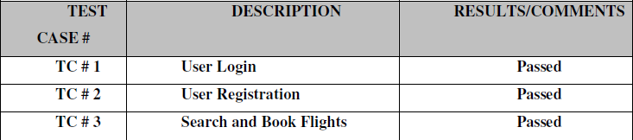

The below table represents the summary of results of testing on the Administrator pages.

The results have been explained in detail later in the document.

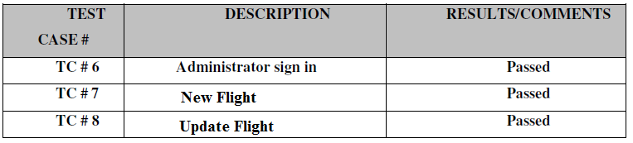

**DETAILED TEST RESULTS**

**MANUAL TESTING**

To start with, We have performed manual testing on the Greeto site

Manual Testing is one of the oldest and rigorous methods of software testing. This

testing strategy gives the best opportunity to check every page thoroughly and make sure it works in the expected manner. Due to the complexity of the various automation tools and the time available for testing the entire application, we preferred to use manual testing based on the fact that it is one of the best methods of testing suggested for a beginner.

All the test cases mentioned in the Test Plan document of Phase II were tested here. The

results of the manual testing are represented in the following tables:

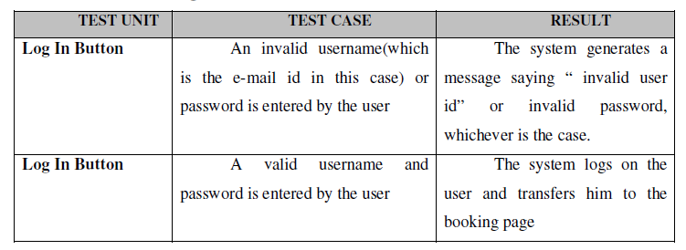**TC # 1 – USER LOGIN**

**TC # 2 – SEARCH AND BOOK FLIGHTS**

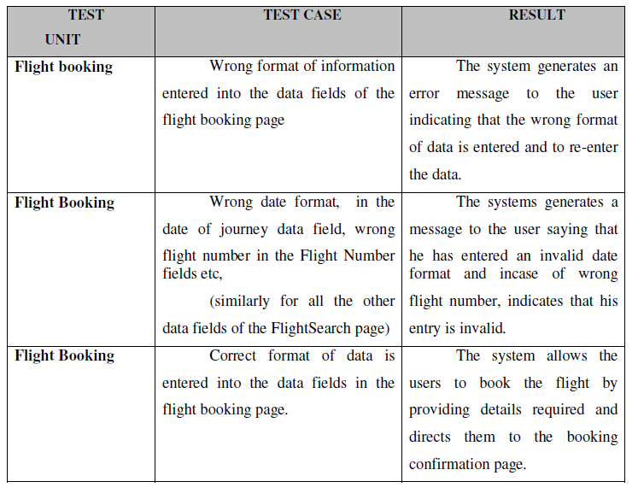

**TC # 3 - ADMINISTRATOR SIGN IN**

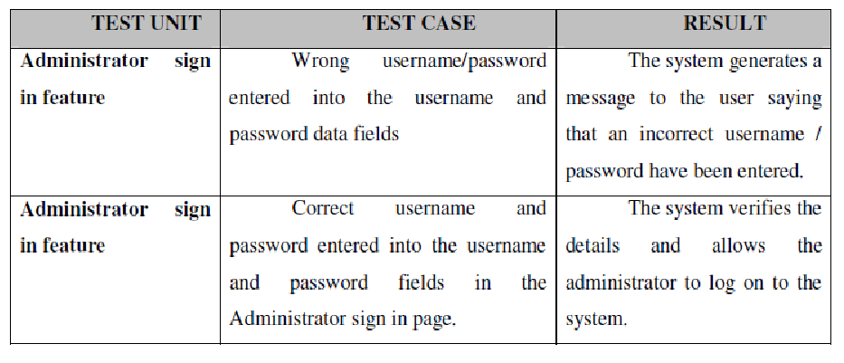

**TC # 4 – NEW FLIGHT ADDITION**

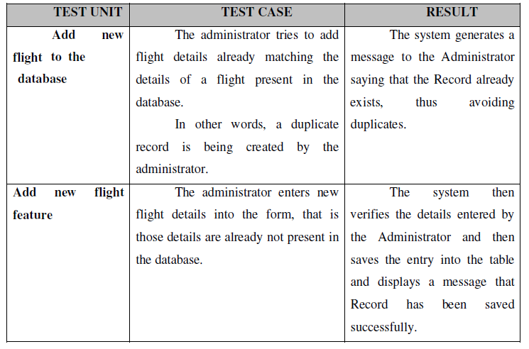

**CONCLUSION:**

**The entire project has been developed and deployed as per the requirements stated by the user, it is found to be bug free as per the testing standards that are implemented. By specification-untraced errors concentrated in the coming versions, which are planned to be developed in near future.**

**The various user requirements are addressed with utmost care and implemented with perfection. The user satisfaction has been achieved by this system. Various aspects of this project can be developed and can be made more sophisticated. The aims and objectives of this initiative has been addressed with necessary attributes.**

**Finally, we like to conclude that we put all our efforts throughout the development of our project to fulfill most of the requirements of the user.**

**References**

[www.w3schools.org](http://www.w3schools.org)

[www.Stackoverflow.com](http://www.Stackoverflow.com)

[www.tutorialspoint.com](http://www.tutorialspoint.com)

[www.wikipedia.org](http://www.wikipedia.org)